November 15 2018 (Issue 1)
Heritage House Newsletter
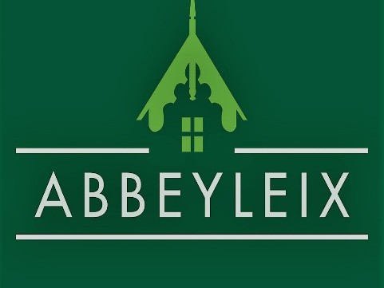

Upcoming Events

November 24
Mad Hatters Hot Chocolate Brunch 11-1pm

December 20
FREE Christmas Storytelling 10-11am

Weekly Activities
Monday 7.30pm Comhaltas Adult Music Classes

Tuesday 11.00am Probus

Tuesday 3.00pm Computer Coding with Isabelle

Friday 10.00am Yoga

From Thursday 10 January 2019 Pilates 10.00am

For further information on these events, or for enquiries about holding an event please contact Heritage House 057 8731653

Monthly Activites

1st Friday of the month Laois Beekeepers Society 7.30-9.30pm

1st/2nd Thursday of the month Home Education Network 12.30pm

Old North School, Abbeyleix
http://www.abbeyleixheritage.com/ T: 057 8731653 E:info@heritagehouse.com
Welcome to the first issue of our monthly newsletter. We here at Heritage House want to keep you updated on events and exhibitions. While many in the locality know where Heritage House is, not everyone may be aware of all that we do.
There is wealth of history to see in our museum from a Bronze age wooden stake to a gas mask used in World War II. There is also plenty of local history on display such as the Mulhall/ Morrissey collection and an exhibition on the Abbeyleix Carpet Factory. For the younger visitor we have a fabulous interactive model railway and a beautiful wooden playground with a full size zip line.
We look forward to keeping our local communities updated with information on our events, exhibitions and community news.

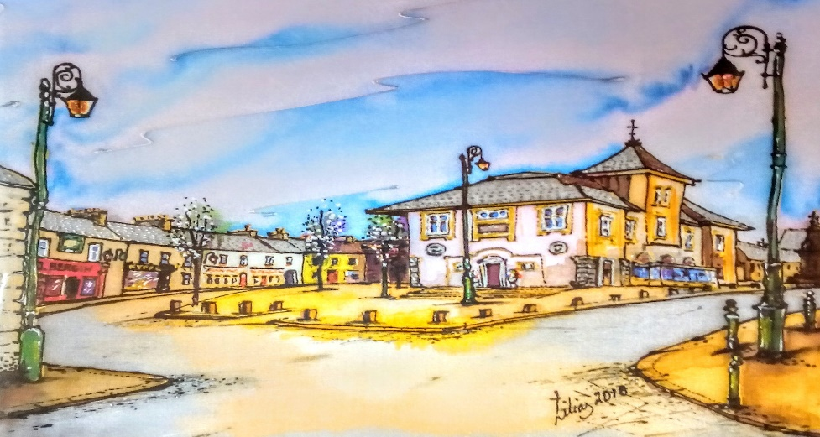

‘Abbeyleix Market House, Market Square’ from original silk painting by Lilias Conroy. A selection of Lilias’ greeting cards are available at Heritage House.

Our Staff
We recently said good-bye to manager Paula Maher and Heritage and Research Assistant Lesley Keogh. We would like to take this opportunity to thank Paula and Lesley for all their hard work.
Welcome to Francine Ashe who has been appointed manager with Regina McGinley as Research and Heritage assistant. Find out more about our new staff in next month’s newsletter.

Recent Events
Heritage House School of Witchcraft and Wizardry
A big thank you to all our budding witches and wizards who came to make magic wands, slime and take part in Beanboozle. There was some fabulously designed wands perfect for spell casting and loads of fun with gooey slime.

Upcoming Events

Did You Know…
The people of Abbeyleix loved their cocoa. In 1941 Morriseys grocery records show that even during the leaner war times a hot chocolate was still a staple of many people’s diet.

Did you Know…
The top hat was invented in 1793 by a hatter from Middlesex called George Dunnage. However, it was not until 1797 that the hat caused quite a stir, when a man named Hertherington, was charged with disturbing public order in England for wearing a top hat while walking down the street.

Mad Hatters Hot Chocolate Brunch 11-1pm €10
Come and decorate your very own top hat then wear it at our Mad Hatters brunch with bottomless mugs of hot chocolate, shrunken pancakes and caterpillar sandwiches.
FREE Christmas Story Telling 10-11am
Take a break from the Christmas rush and join us for Christmas stories from around the world while enjoying a mince pie and a cup of something hot. If you have any suggestions for books or stories you would like read, please contact us. Suitable for all ages.
Home Education Network Meetings 12-30-4.30pm €4
This group meeting is a chance for home educated children to socialize as well as take part in activities, workshops and talks. New members are always welcome and it is especially useful for those considering home schooling in the future.
Next meeting is Thursday the 6th December and the group usually meets on the 1st or 2nd Thursday of the month. Cost is €4 per family. For further information contact Tracey on 085 7616443.

Competition Winner
In October we ran a competition for one of our followers to win an hours genealogical consultation. Our winner is Caroline Dunlea. Congratulations Caroline!
Keep an eye on our Facebook page for similar competitions in the New Year. Meanwhile, should you have any genealogical queries, contact our resident researcher Regina at research@abbeyleixheritage.com.

Film Review
Our part-time research assistant Shay McCauley has been reviewing Scott Pilgrim V’s The World.
Scott Pilgrim is a 2010 film directed by Edgar Wright. This film stars Michel Crea and Mary Elizabeth Winstead as the respective Scott and Ramona. This film centres on both characters, as they have to face Ramona’s evil exes and their baggage while improving as people. This occurs through various battles based on extremely lose video game logic.
This is where Edgar Wright’s signature fast-paced editing style can really shine. The battles flow with their various anime styles and pack a punch more often than not, while the comic book transitions helps the film to remain interesting throughout.
However, a weak point of the film are the characters. While both Scott and Ramona have similar arcs, they are different to their comic book counterparts. The more detail the graphic novels go into allows us to understand the characters a lot better than we do by the end of the film. We get their various growth and changes, which allows us to see these character’s more as people than the film leaves us with.

Looking for a Christmas gift?
We are lucky enough to have a small selection of beautifully designed coasters and bags based on Irish heritage by Angelina Foster from Angelina’s Art Ventures. An ideal gift for Christmas.

We also have a range of local history books, including a beautiful new release ‘Mapping Laois’ by Arnold Horner which explores the history of Laois through its historical maps. Price €30.

Time and Tide……………...……….€5
It started in the Jelly’s Pit………€5
Abbeyleix Celebrating 100 years of the ICA…………………………………€10 Hidden in the Pile……………..…..€10
Abbeyleix Life Lore & Legend..€10
Portarlington the Old Town…..€10
From Here to the Horizon……..€10 The Crows Enchanted Dance...€12 From Laois to Kerry………...……€20

Coming Soon
Laois Heritage Journal Volume 9 will be launched on the 23 November in Portlaoise Parish Hall at 7.30pm.
This edition has an article from our researcher Regina titled ‘Queens County and the 1918 Election’.

While muted I do think that the film and story can be invaluable to young people who can start dating and navigating the world with the idea that self-respect is better than love, but the way the film gets there feels under cooked. While it is something I appreciated, I cannot help but feel the detail and plot of the comics allowed it to land better. In the end, I enjoyed what the film had to offer; it had a goal and some fun getting there so I cannot complain.

